My Callender App --Maksaud--

5/06/19

I started on the of the app. The idea of the app was to allow you to use the calender in order to manage time. It originally had a page where you could check the weather and allows you to check for events in your area but I didn’t know how to do that and thought of adding it in only if I had time to learn more about it and research.

6/06/19

Finnished with my designed and added a secondary design called nightmode for users with special prefferences.

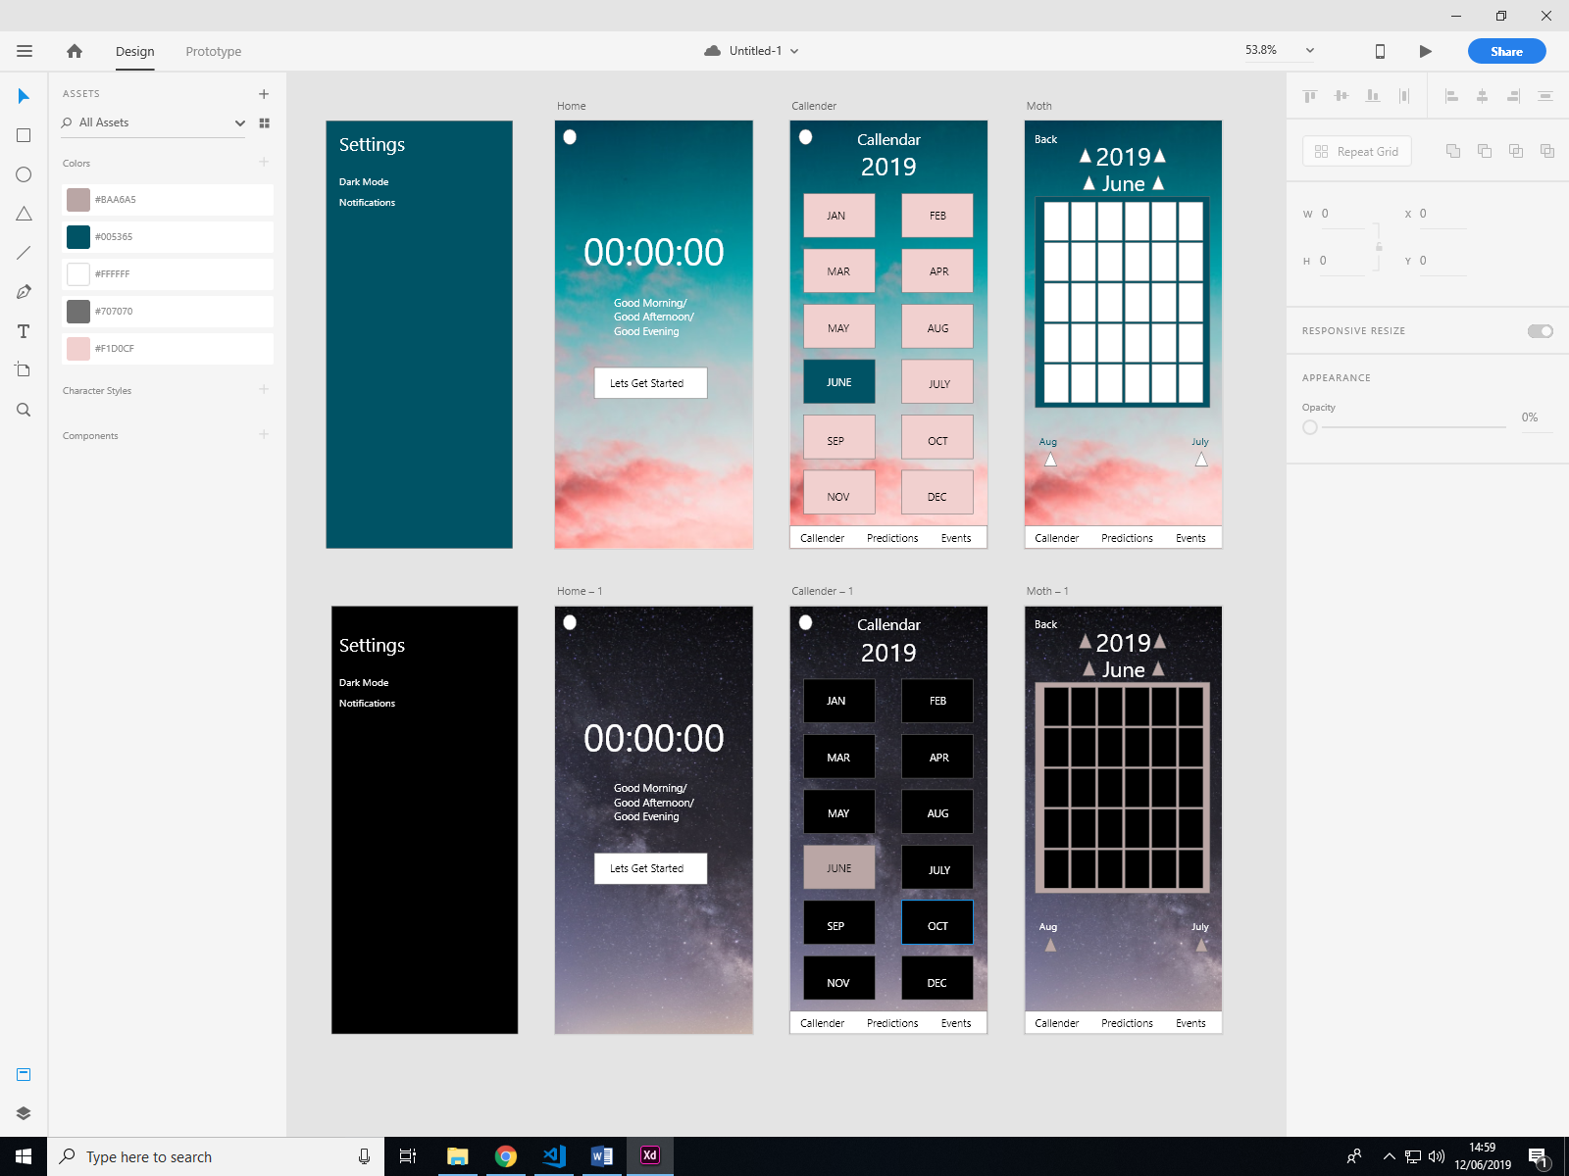I started coding the index page and the callender page but came across a problem where my routes stopped working (worked at first) couldn’t fix it so decided after I code evething front end wise, I will download another template and put my HTML, JS, CSS in.

11/06/19

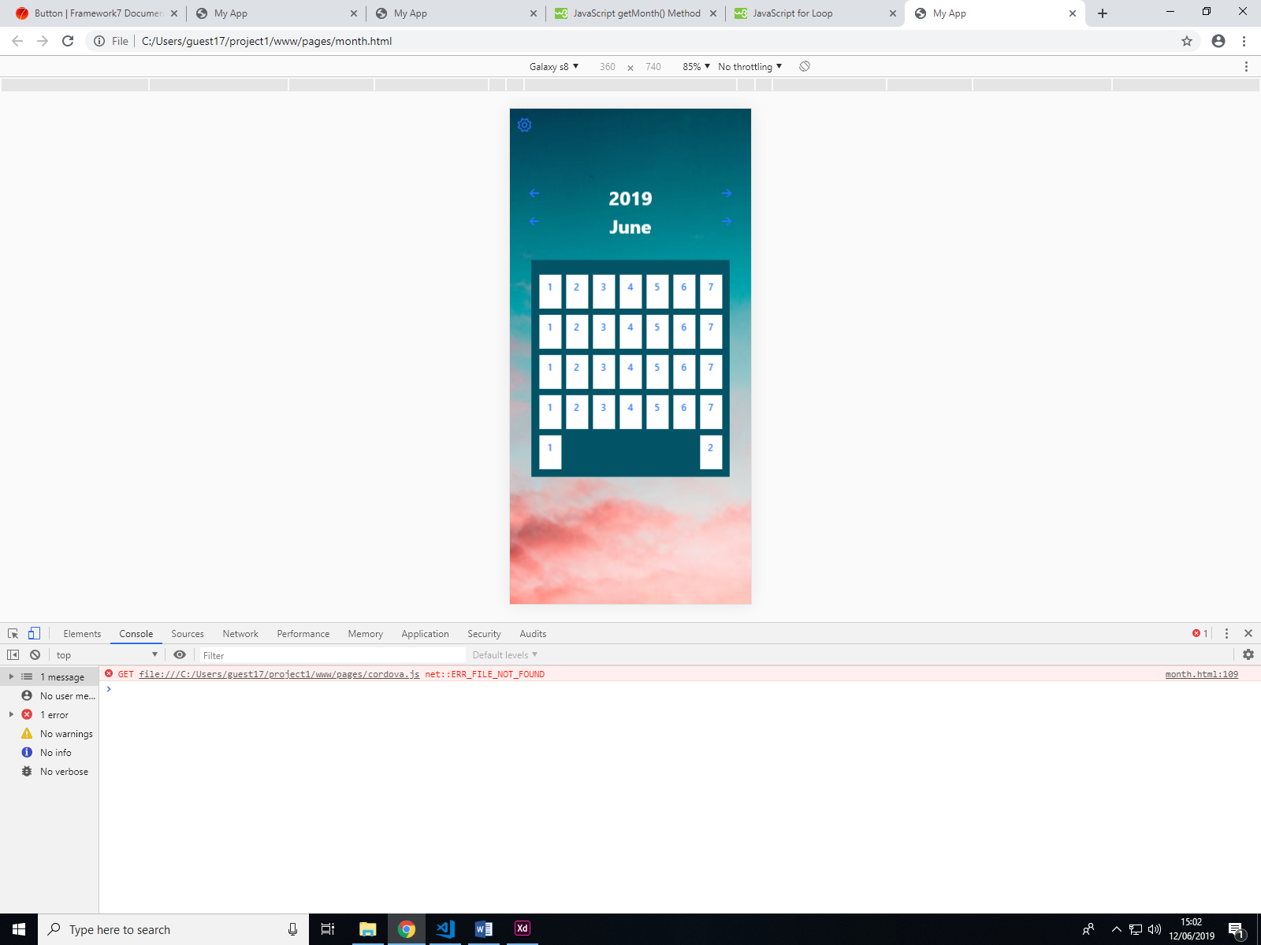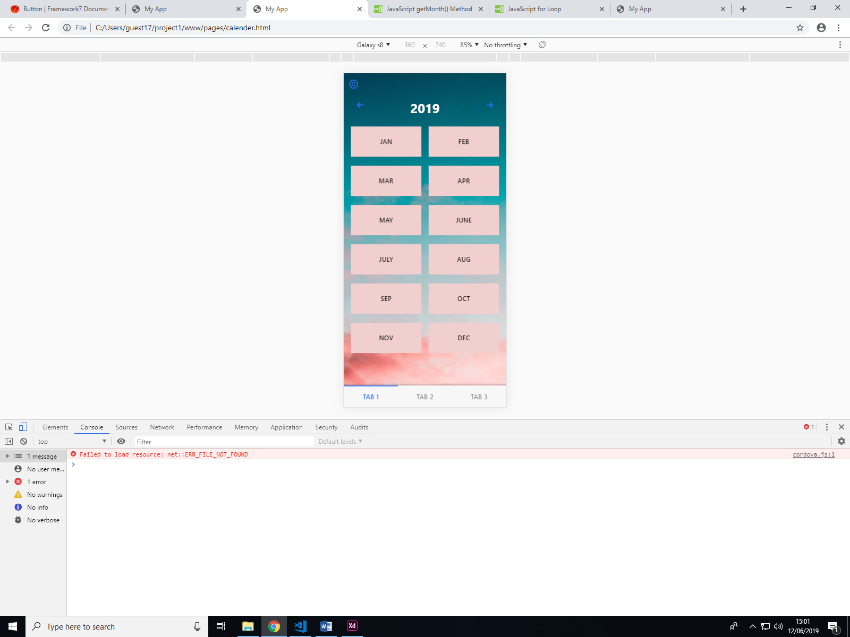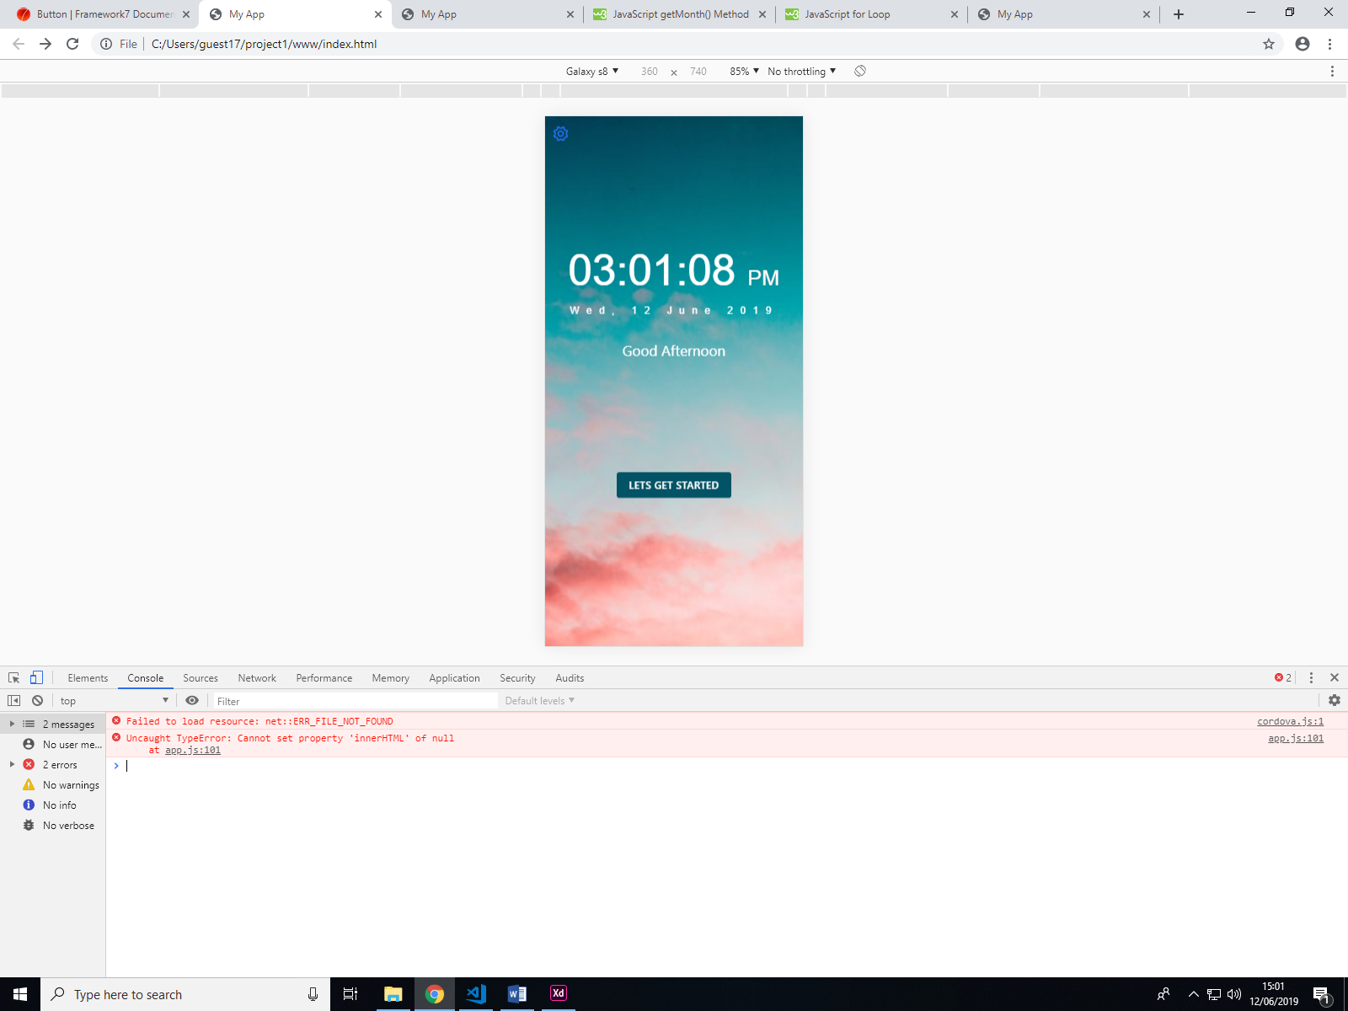Carried on coding the front end of the app and started working on the javascript on the callender. It had to use calculations and date methods to be able to get the dates and subtract or add from the original.

Uses JavaScript

12/06/19

I added more to the html and css and thought about started to download the new template for the routes to work as it would be cruicial to bring all my js together since the calculations don’t just 1 page but multiple pages.